Report: Optimising NYC Taxi Operations

Include your visualisations, analysis, results, insights, and outcomes. Explain your methodology and approach to the tasks. Add your conclusions to the sections.

## Data Preparation

* 1. Loading the dataset

I loaded one file from the 12 files and then realized that it is a big data. So went ahead with sampling.

* + 1. **Sample the data and combine the files**

I have used path from the D drive from my computer and took sampled of **1%** for each date and hour.

For the hour and date, I have used the column**, tpep_pickup_datetime** to extract the hour and date.

Then using joblib I saved the 1% data file to my computer in the form of parquet file named **“Samples File - 1pct”**

I named the DataFrame **“sampled_df”**

## Data Cleaning

### Fixing Columns

* + - **Fix the index**  
      I brough the columns “hour” and “date” in index 1 and 2.

I removed the column **“tpep_pickup_datetime”**, but later in Section 3, I had to restore it due to the requirement for pickup time data.

* + 1. **Combine the two airport_fee columns**
* Replaced NaN values with 1 to enable adding the two columns.
* Then I added the two columns in one column named **“total_airport_fee”**

### Handling Missing Values

* + 1. **Find the proportion of missing values in each column**

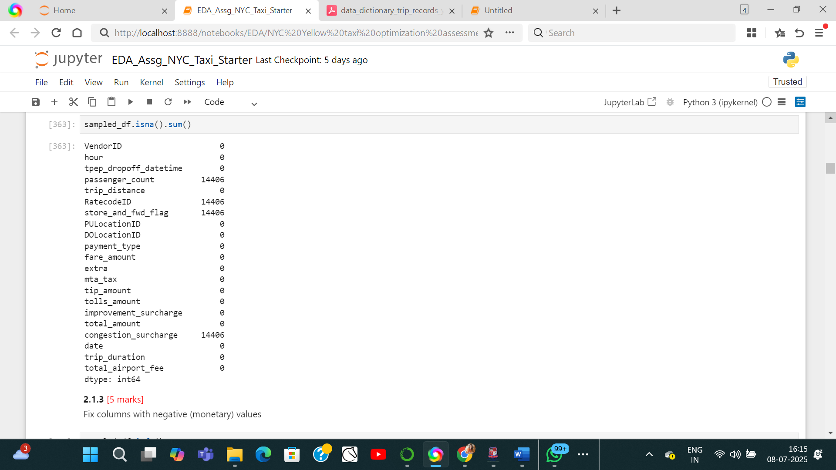

**Columns having null values:** passenger_count, RatecodeID, store_and_fwd_flag, congestion_surcharge

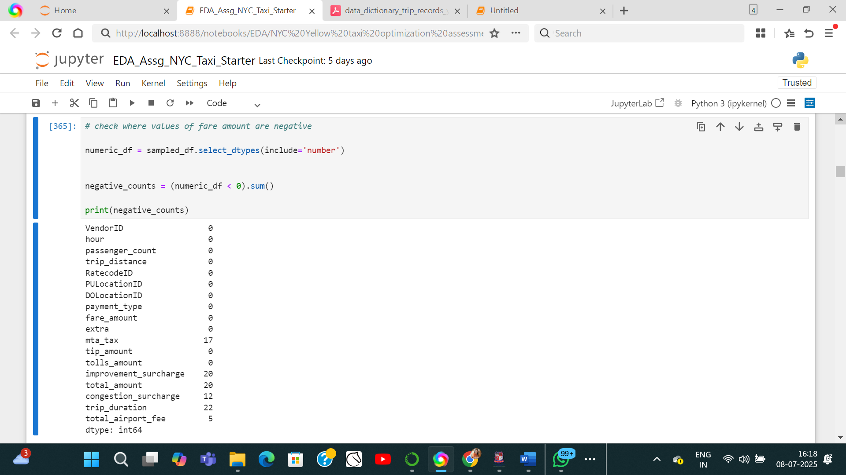

Columns having negative values: mta_tax, improvemnet_surcharge, total_amount, congestion_surcharge, trip_duration, total_airport_fee

* + 1. **Handling missing values in passenger_count**

Number of null entries in 'passenger_count': 14406

Median of entries in 'passenger_count': 1.0

**So I replaced the missing passenger count by median value.**

Zero entries in 'passenger_count': 6907

Percentage of zero entries in 'passenger_count': 1.54%, hence we may drop this small number of rows.

The passenger count rows with zero entries is dropped.

* + 1. **Handle missing values in RatecodeID**

Number of null entries in 'RatecodeID': 14406

Percentage of null entries in 'RatecodeID': 3.2547326469611426% .

Unusual value “99” is seen in the RatecodeID data.

**Dropped RatecodeID with 99 and replace NaN values with 1 (i.e the usual ratecode ID as per data).**

* + 1. **Impute NaN in congestion_surcharge**The count of null values in congestion_surcharge is:14418

The mean of congestion_surcharge is:2.32

The median of congestion_surcharge is:2.5

Null values are replaced with median value “2.5”

**Impute NaN in store_and_fwd_flag**

N: 423337

Y: 2377

Null: 14406

Total: 440120

**Null values are replaced by N**

### Handling Outliers and Standardising Values

* + 1. **Check outliers in payment type, trip distance and tip amount columns**

**The outliers are identified using box plot.**

**Payment type:**

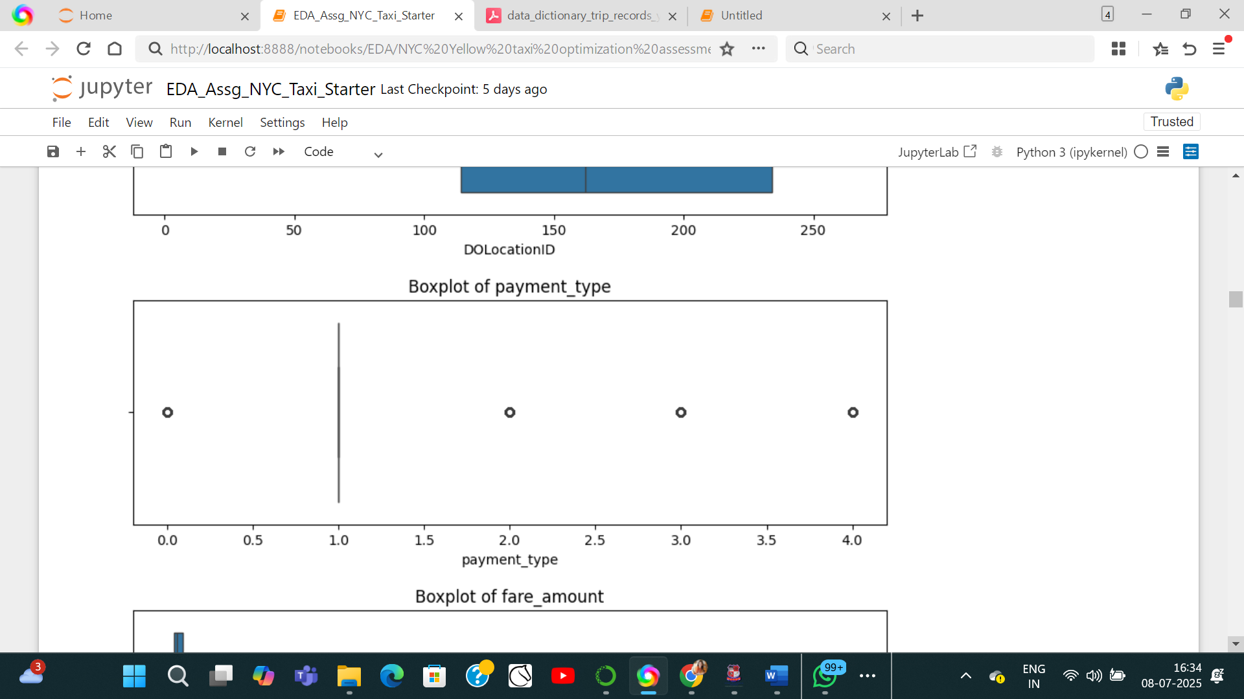

**Trip distance:**

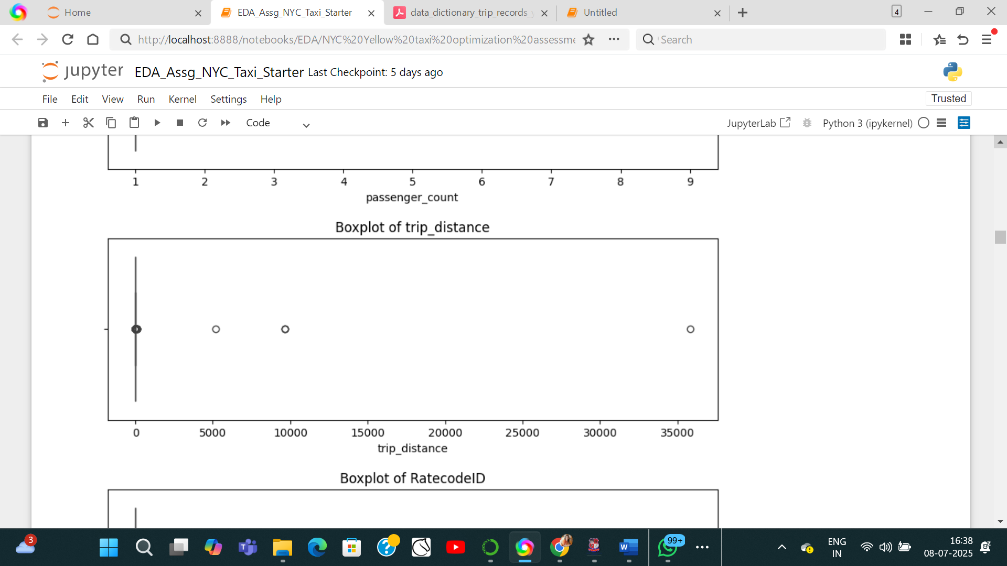

**Tip amount:**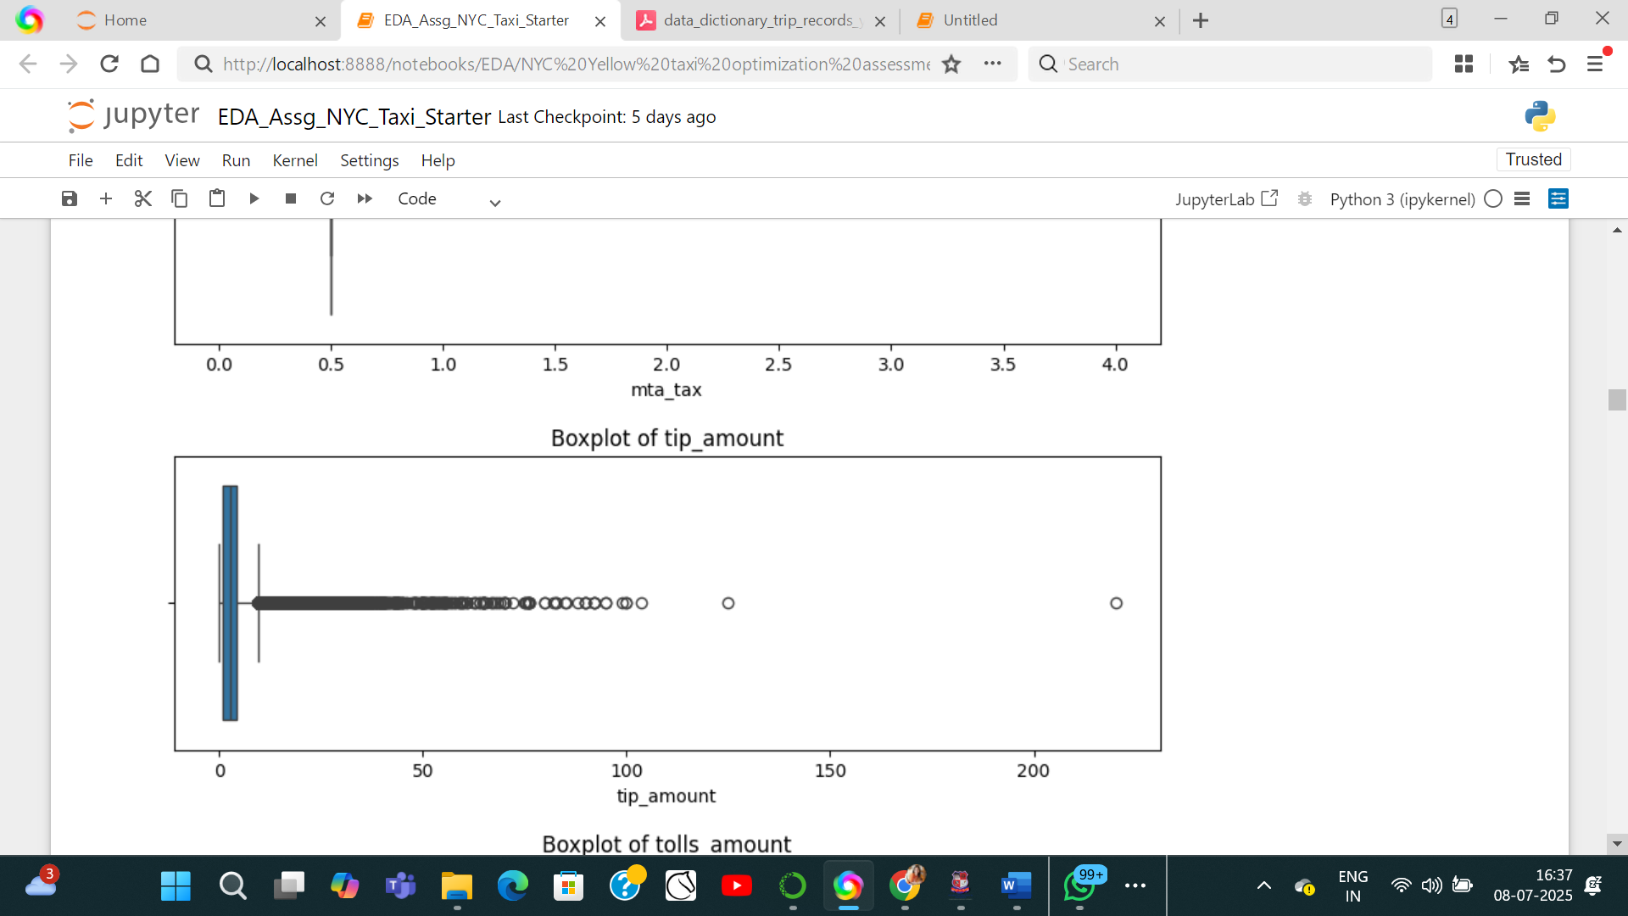

## Exploratory Data Analysis

### General EDA: Finding Patterns and Trends

**Classify variables into categorical and numerical**Categorise the varaibles into Numerical or Categorical.

VendorID: Categorical

tpep_pickup_datetime: Date time - Numerical

tpep_dropoff_datetime: Date time - Numerical

passenger_count:Categorical

trip_distance: Numerical

RatecodeID:Categorical

PULocationID: Numerical

DOLocationID: Numerical

payment_type:Categorical

pickup_hour:Categorical

trip_duration: Numerical

fare_amount: Numerical

extra: Numerical

mta_tax: Numerical

tip_amount: Numerical

tolls_amount: Categorical

improvement_surcharge: Categorical

total_amount: Numerical

congestion_surcharge: Categorical

airport_fee: Numerical

* + 1. **Analyse the distribution of taxi pickups by hours, days of the week, and months**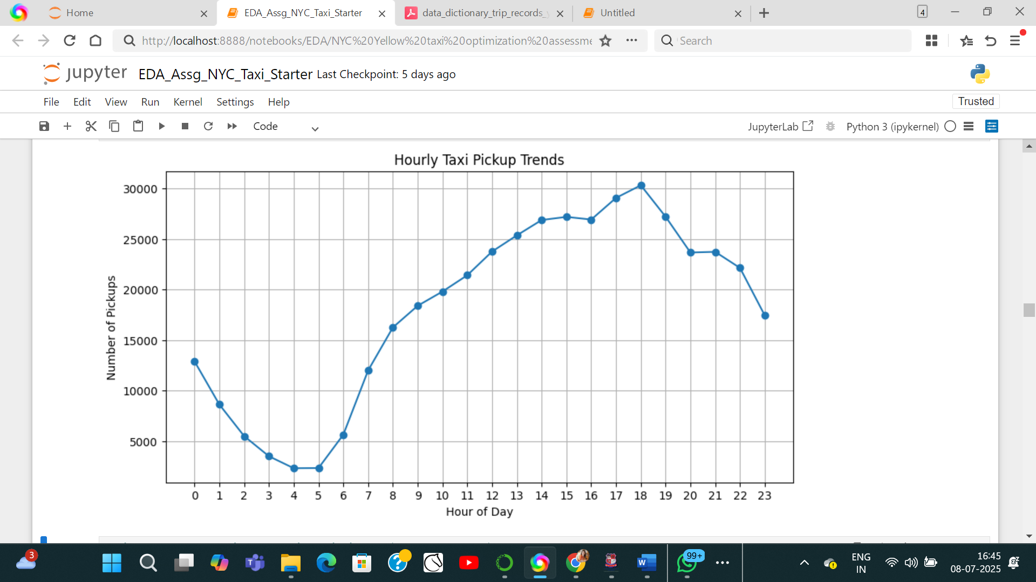

**Monthly/daily:**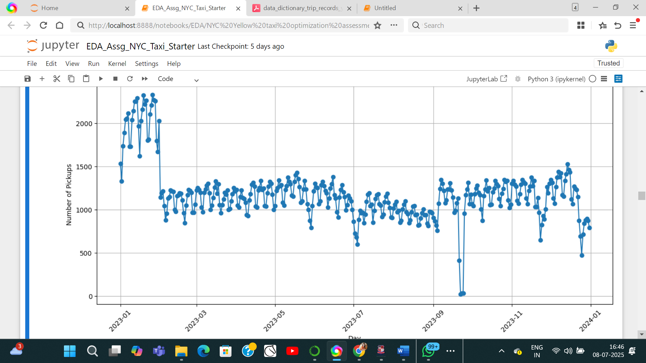

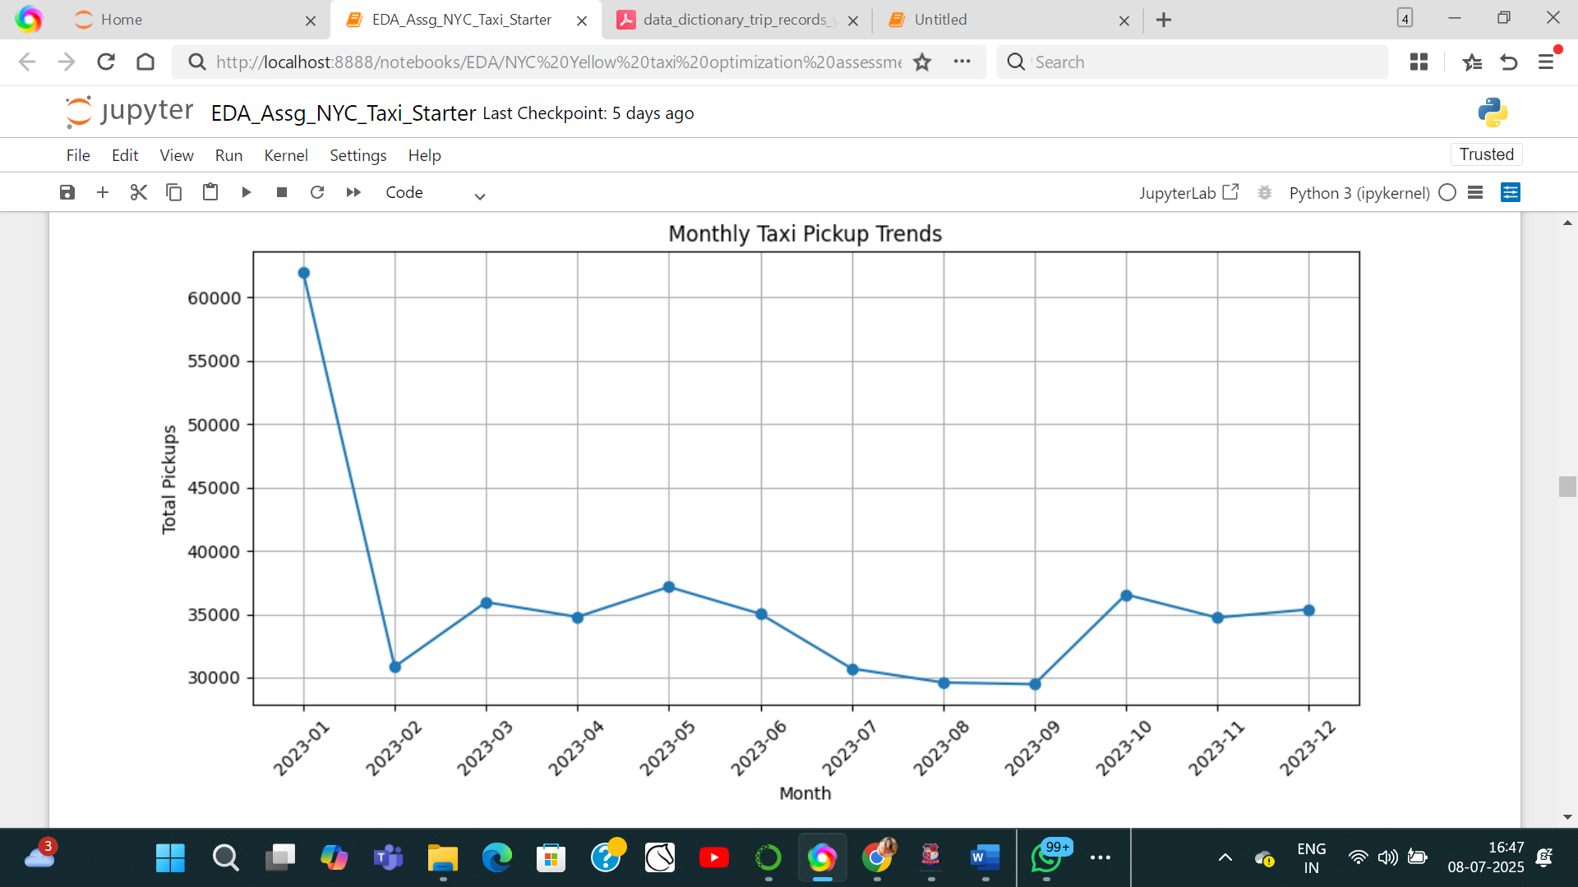

* + 1. **Filter out the zero/negative values in fares, distance and tips**I had filtered negative columns in the second section.

**Analyse the monthly revenue trends** month total_amount

0 2023-01 1377752.22

1 2023-02 689164.54

2 2023-03 831487.49

3 2023-04 810260.33

4 2023-05 883369.36

5 2023-06 834821.79

6 2023-07 689553.27

7 2023-08 676301.55

8 2023-09 722130.83

9 2023-10 890484.14

10 2023-11 837455.22

11 2023-12 823104.01

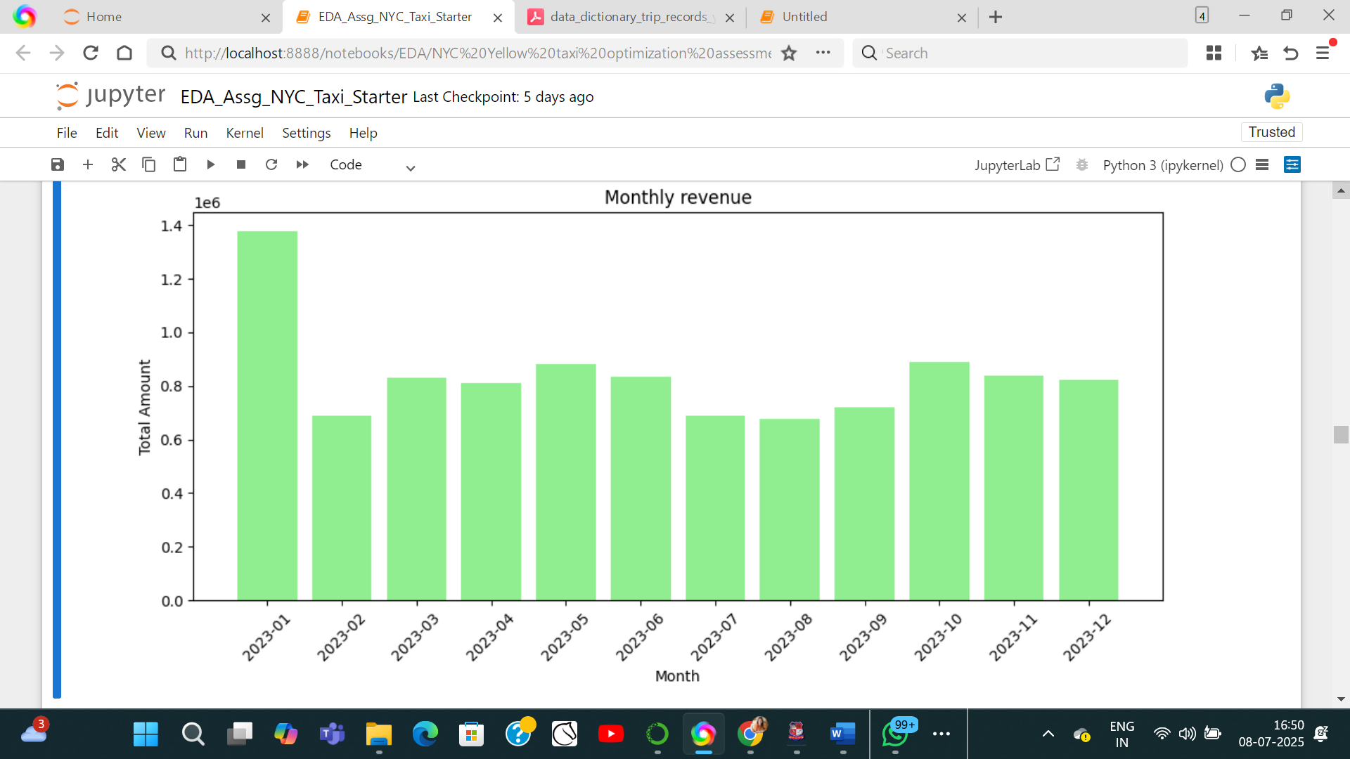

* + 1. **Find the proportion of each quarter’s revenue in the yearly revenue  
        quarter total_amount**

**0 2023Q1 2898404.25**

**1 2023Q2 2528451.48**

**2 2023Q3 2087985.65**

**3 2023Q4 2551043.37**

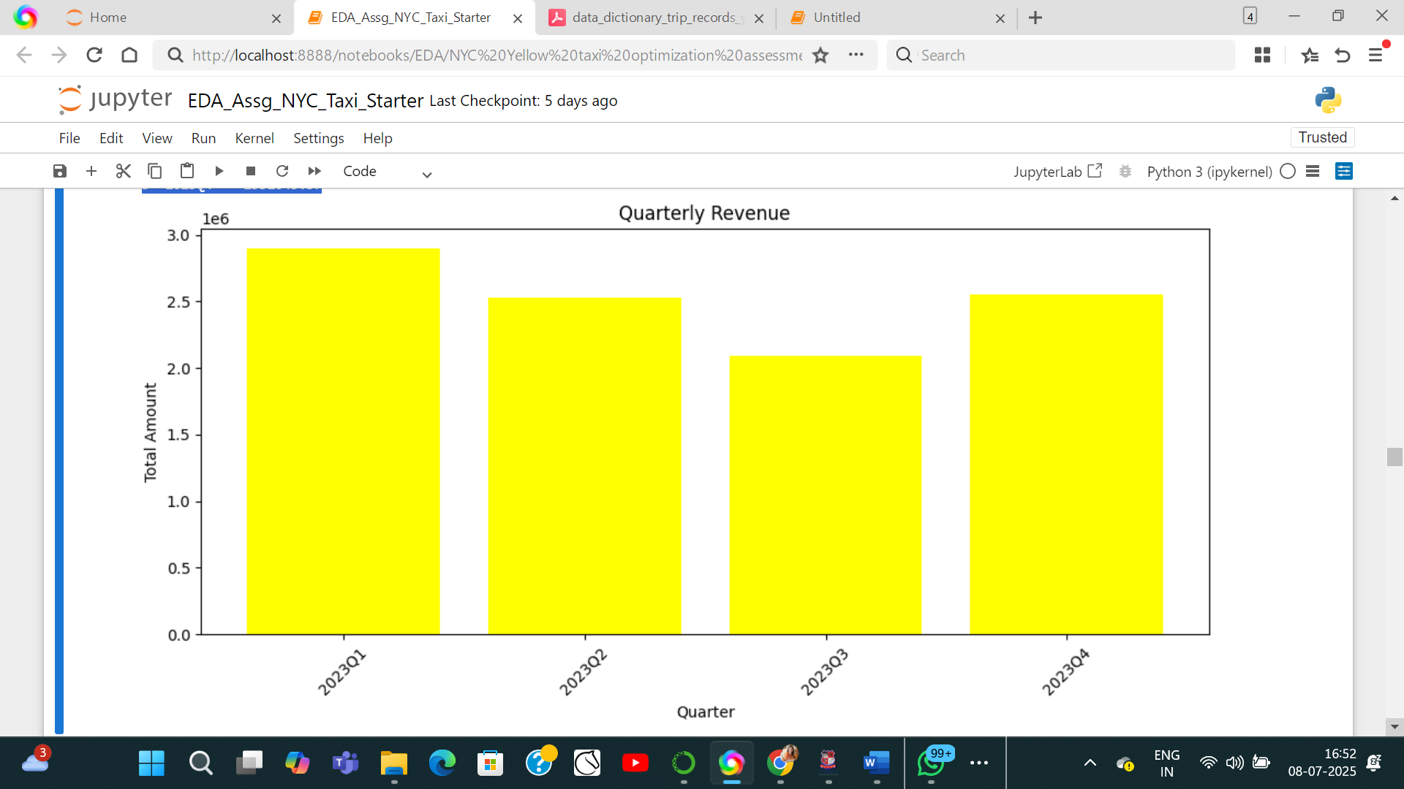

* + 1. **Analyse and visualise the relationship between distance and fare amount**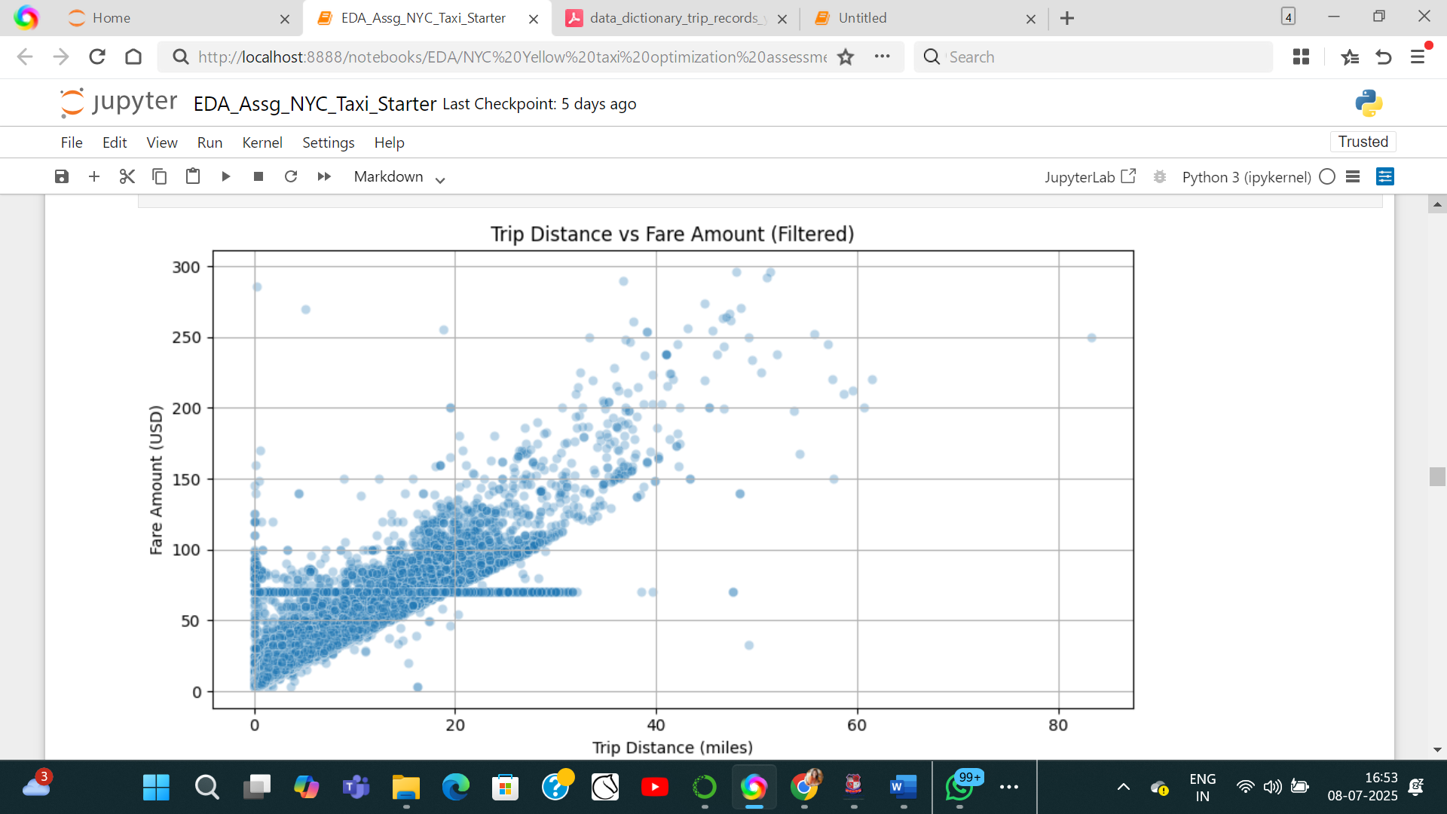
    2. **Analyse the relationship between fare/tips and trips/passengers**

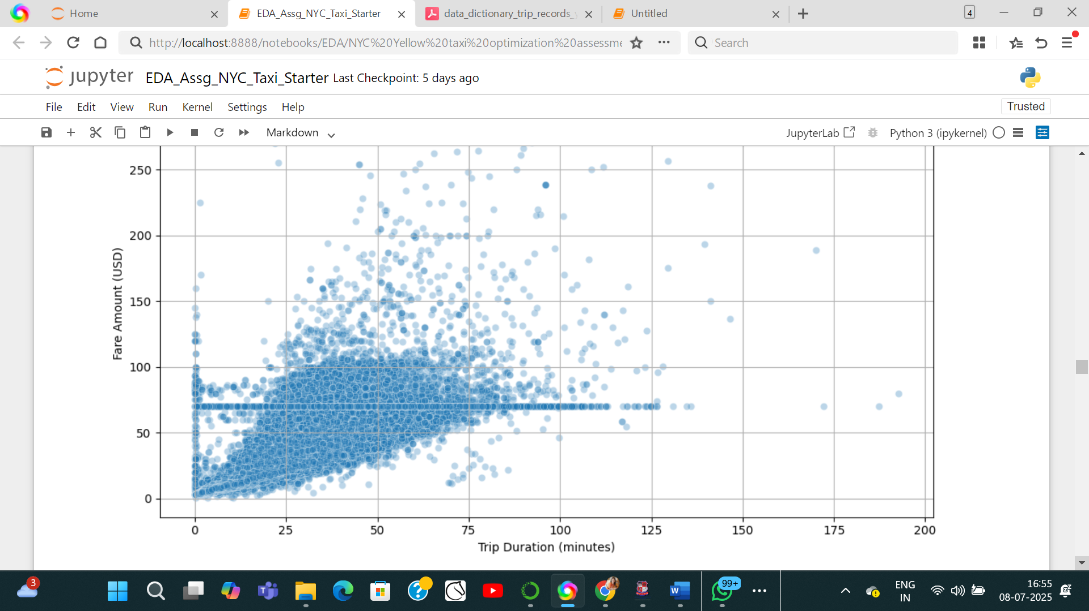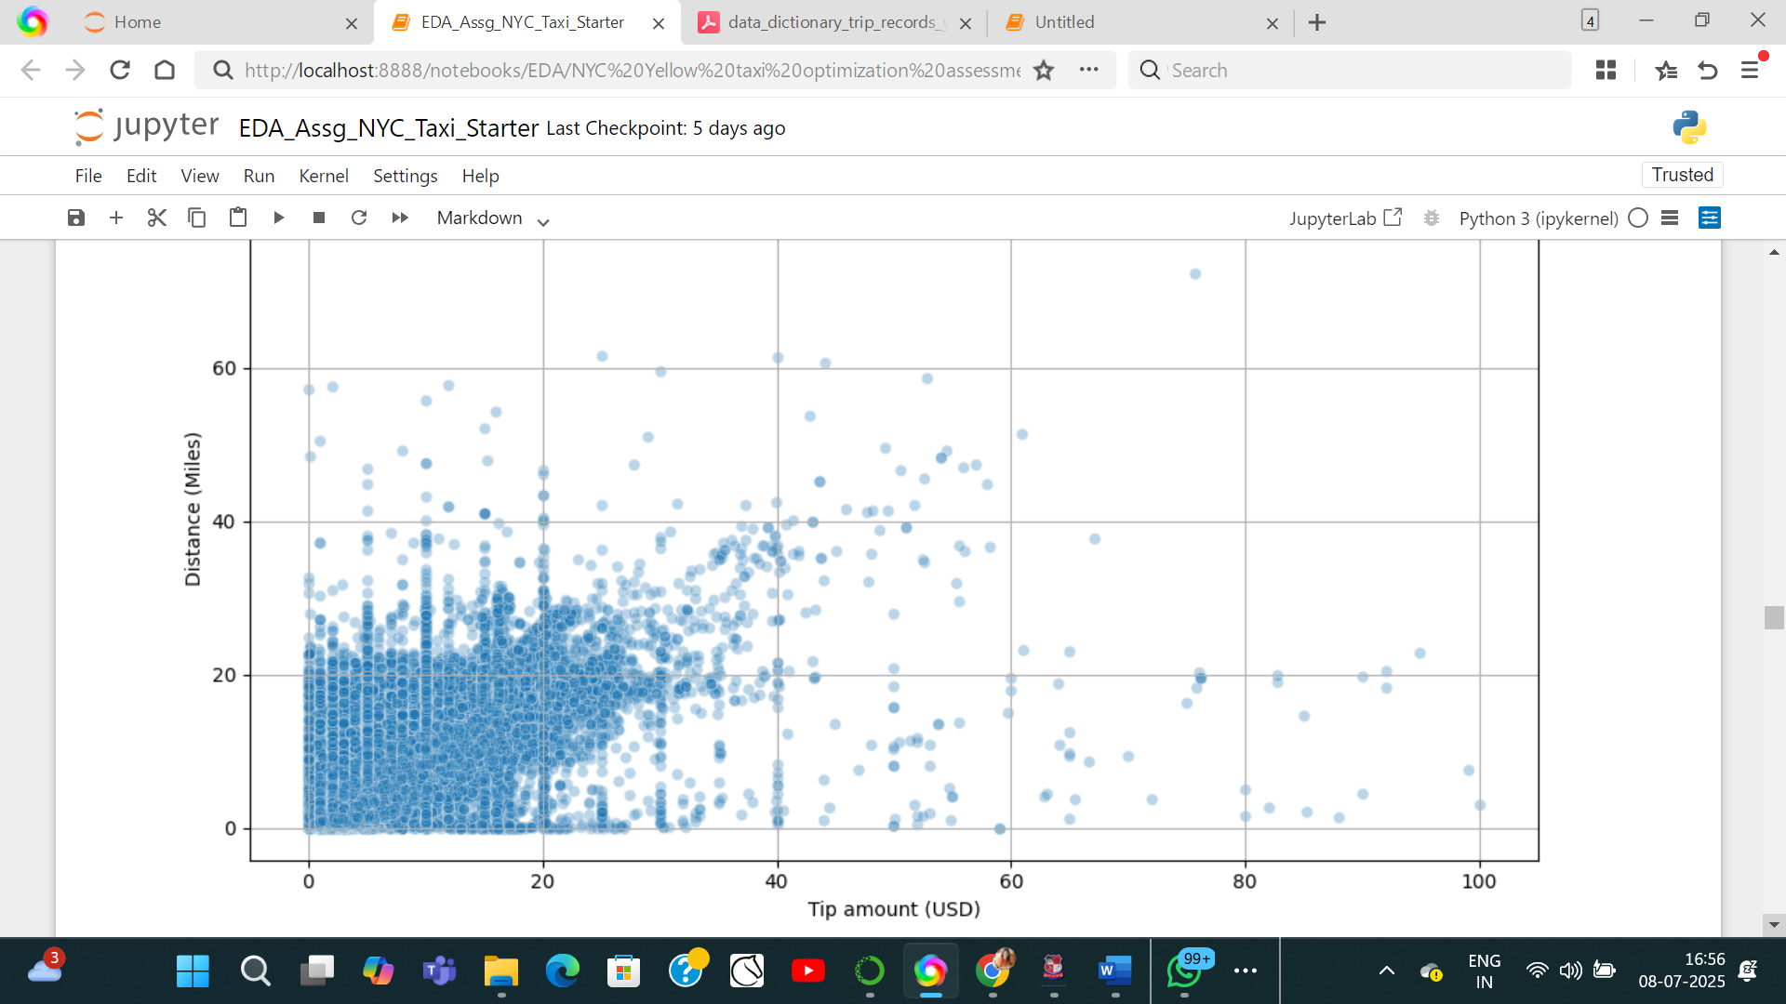

* + 1. **Analyse the distribution of different payment types**Payment Type Percentages:

payment_type

1 99.99

2 0.00

4 0.00

3 0.00

* + 1. **Load the taxi zones shapefile and display it**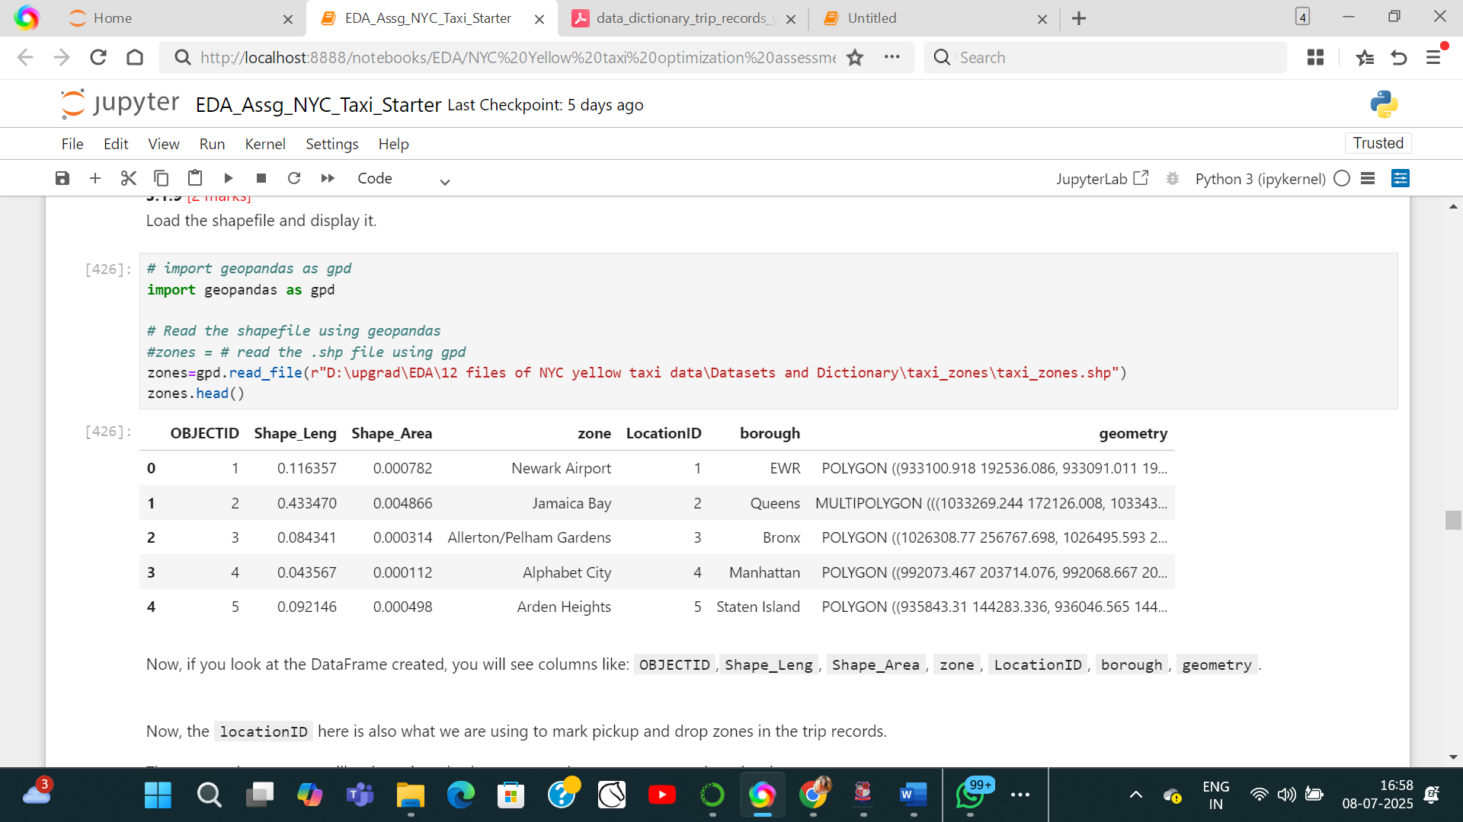
    2. **Merge the zone data with trips data**merged_df = sampled_df.merge(zones, left_on='PULocationID', right_on='LocationID', how='left')
    3. **Find the number of trips for each zone/location ID**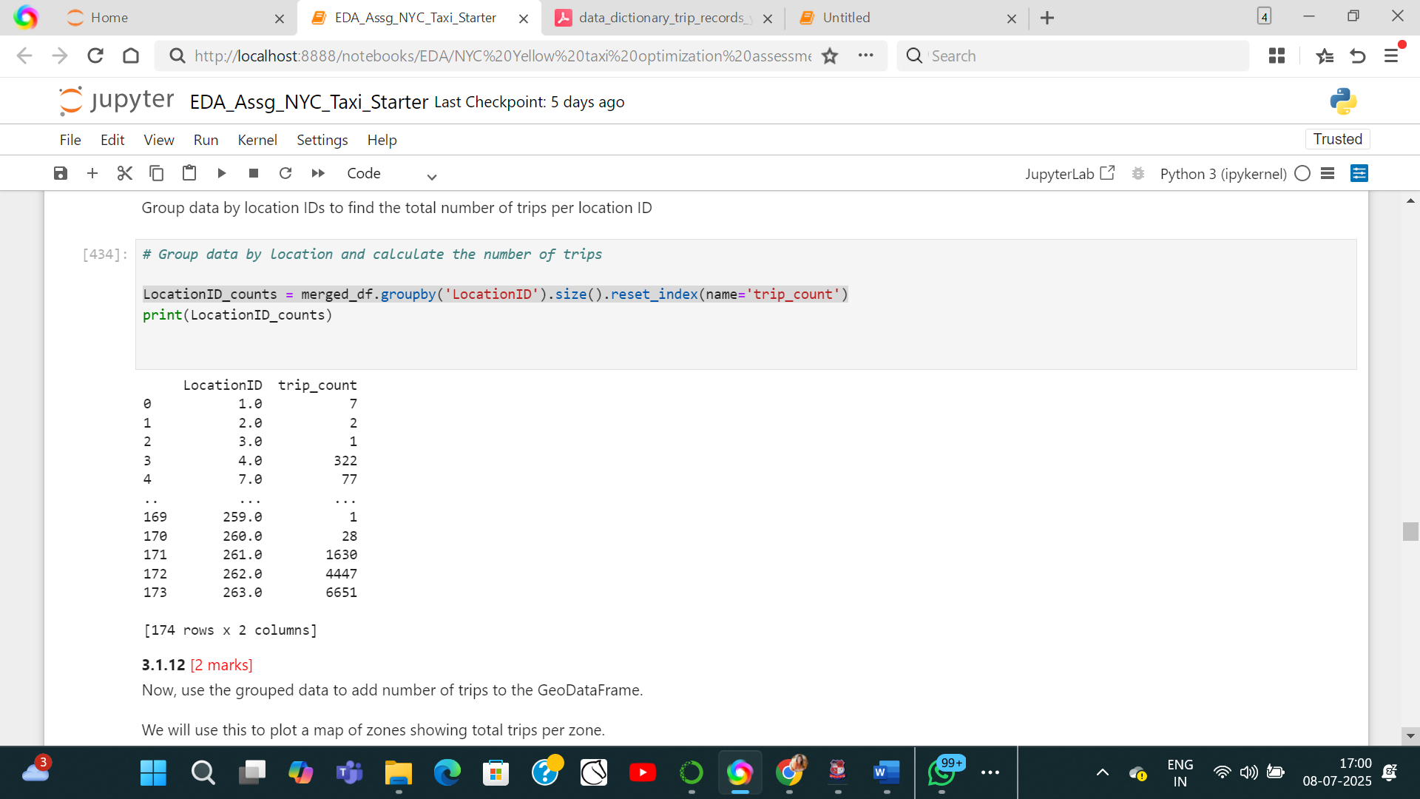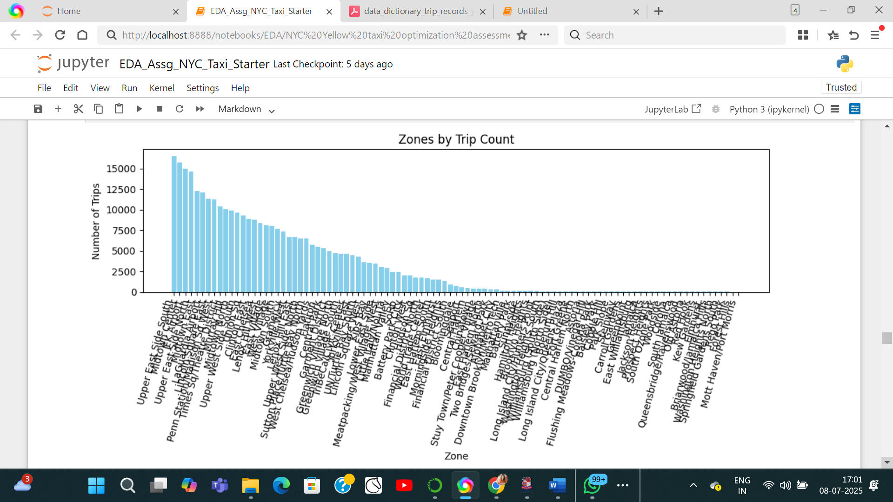
    4. **Add the number of trips for each zone to the zones dataframe**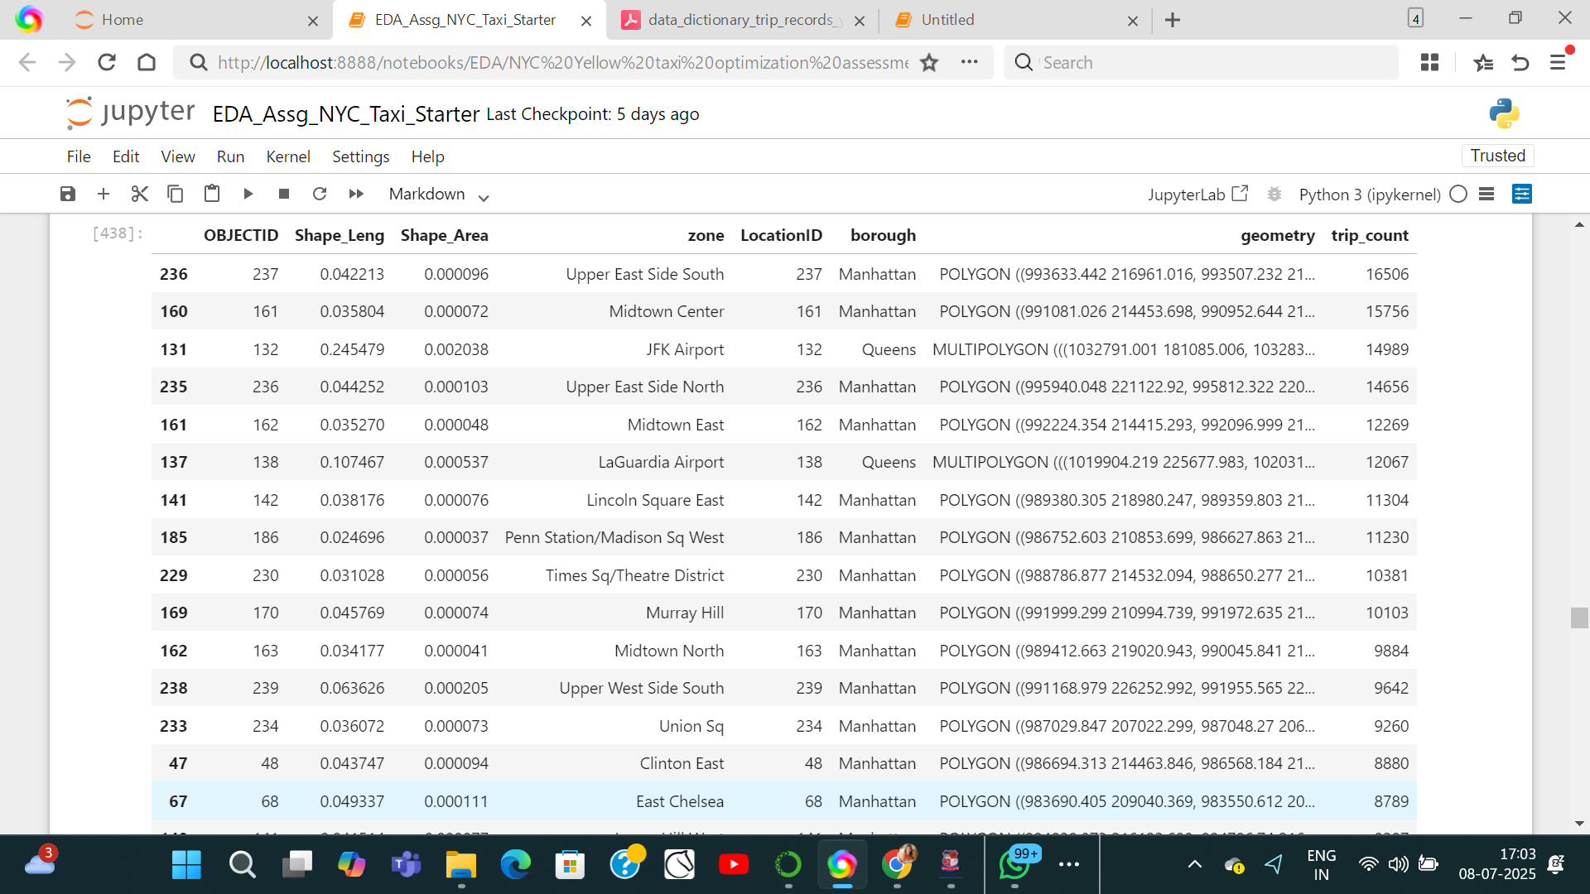
    5. **Plot a map of the zones showing number of trips**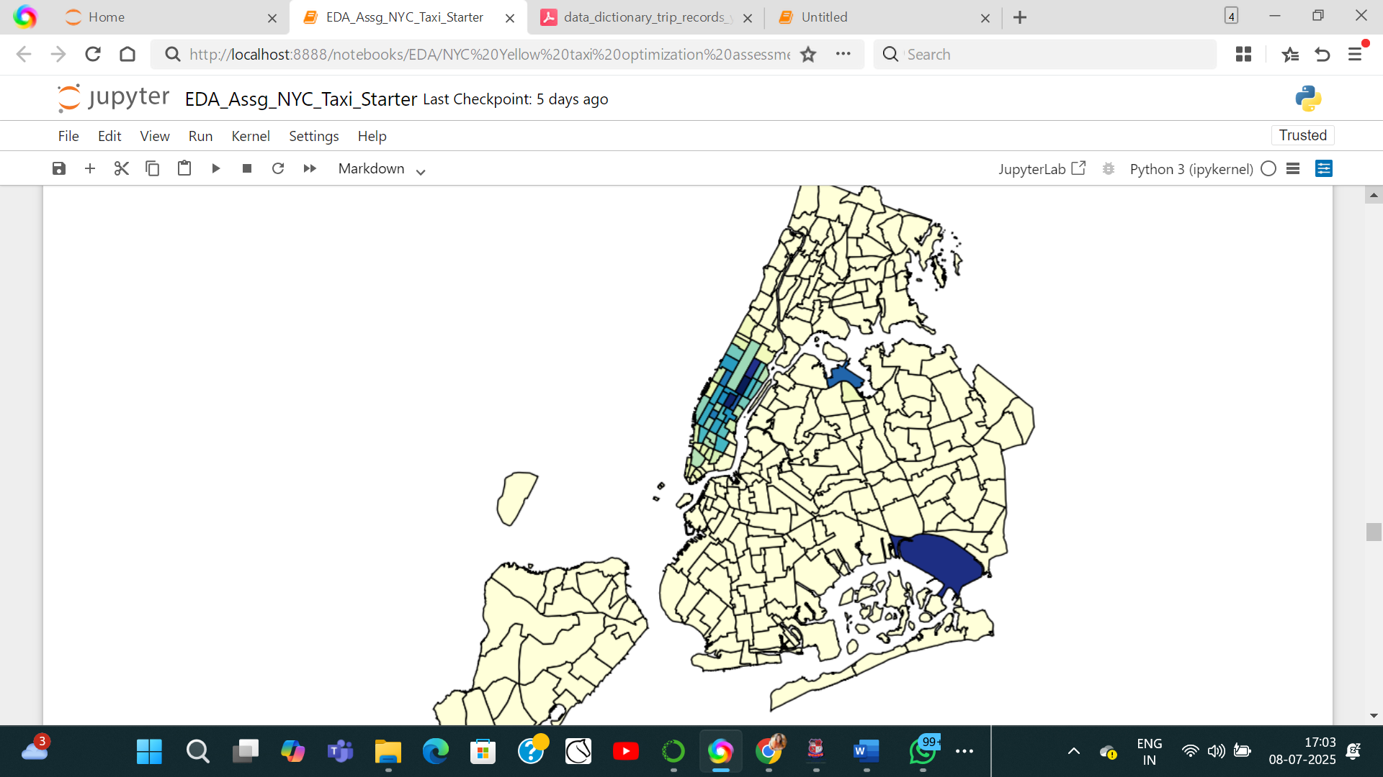
    6. **Conclude with results**
* Busiest hours, days and months:

Busiest months in descending order: January, October, May, November, June, march, Descember, April, September, February, July, August.

Busiest dates: January 2023

Hours: 10th -24th hour. Highest picups in 19th hour

* Trends in revenue collected:

Monthly revenue collected:

0 2023-01 1377752.22

1 2023-02 689164.54

2 2023-03 831487.49

3 2023-04 810260.33

4 2023-05 883369.36

5 2023-06 834821.79

6 2023-07 689553.27

7 2023-08 676301.55

8 2023-09 722130.83

9 2023-10 890484.14

10 2023-11 837455.22

11 2023-12 823104.01

* Trends in quarterly revenue:

quarter total_amount

0 2023Q1 2898404.25

1 2023Q2 2528451.48

2 2023Q3 2087985.65

3 2023Q4 2551043.37

* How fare depends on trip distance, trip duration and passenger counts:
* fare amount is mostly equally proportionate to Trip distance.
* Generally long trip duration implies long distances. Hence, fare in crease as duration increases, but- some entries that needs to be considered where fare is the same even if durations are long.
* Graphical representations indicate that passenger count is inversely proportional to fare amount.
* How tip amount depends on trip distance:
* Tip amount is equally proportionate to trip distances.
* Busiest zones:

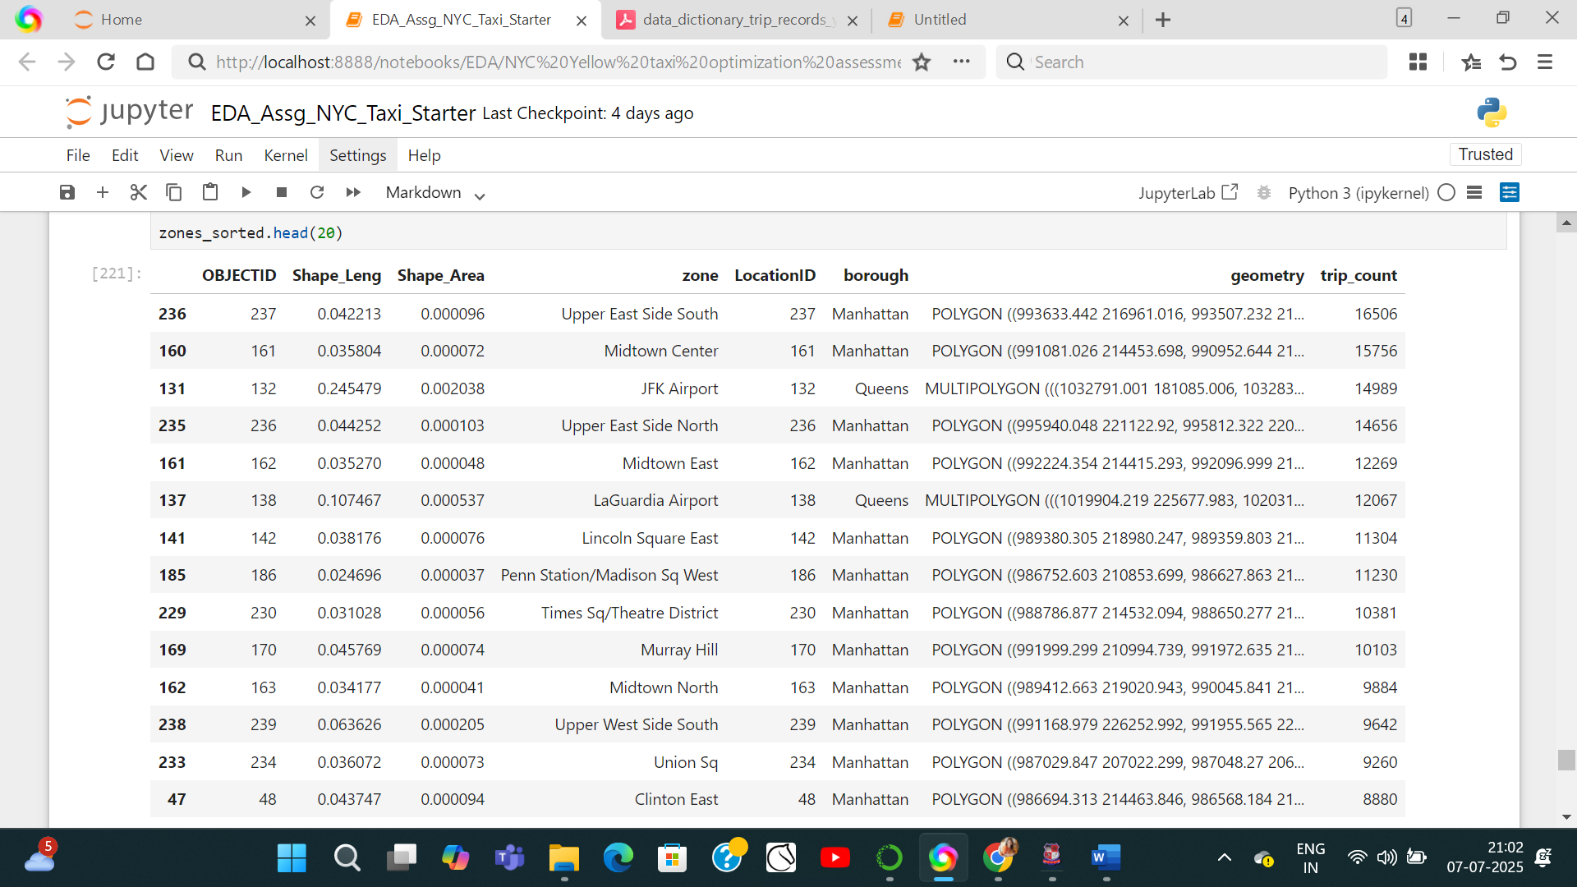

### Detailed EDA: Insights and Strategies

* + 1. **Identify slow routes by comparing average speeds on different routes**

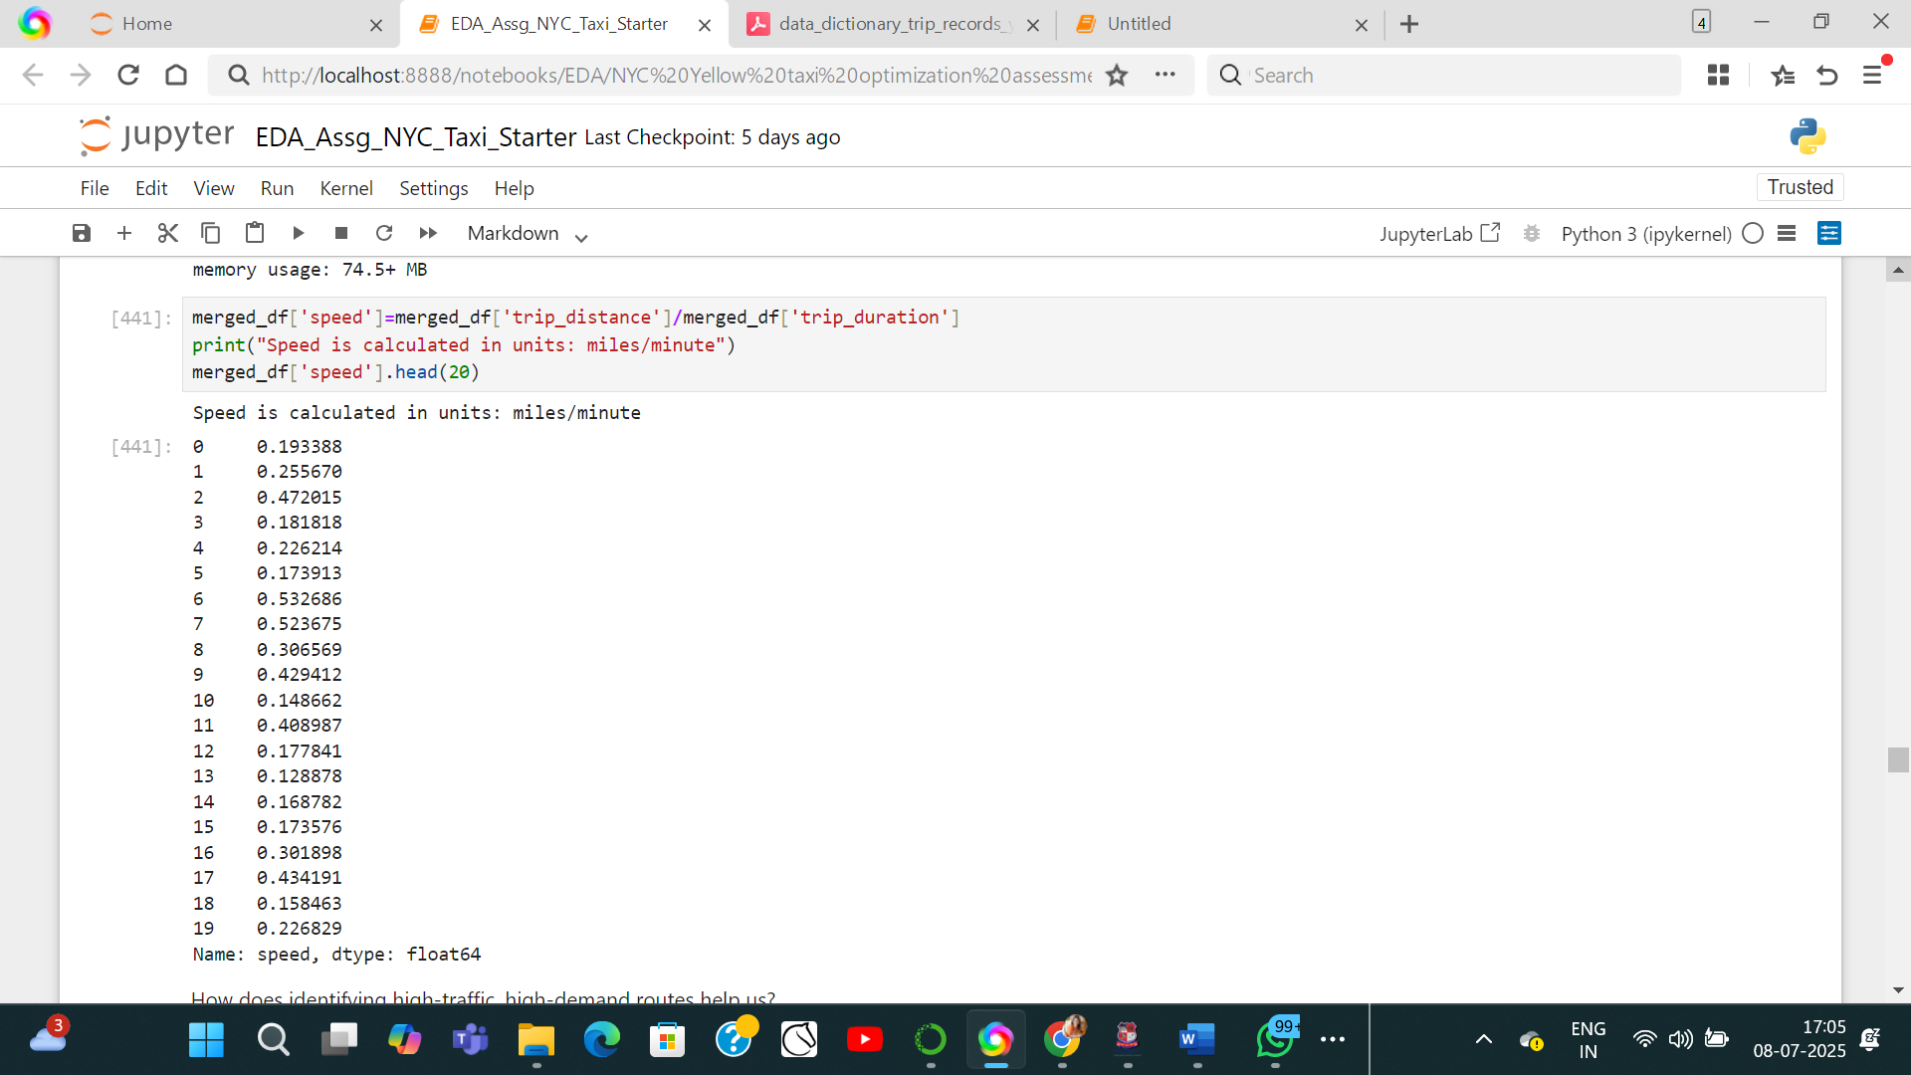 **fast zones**

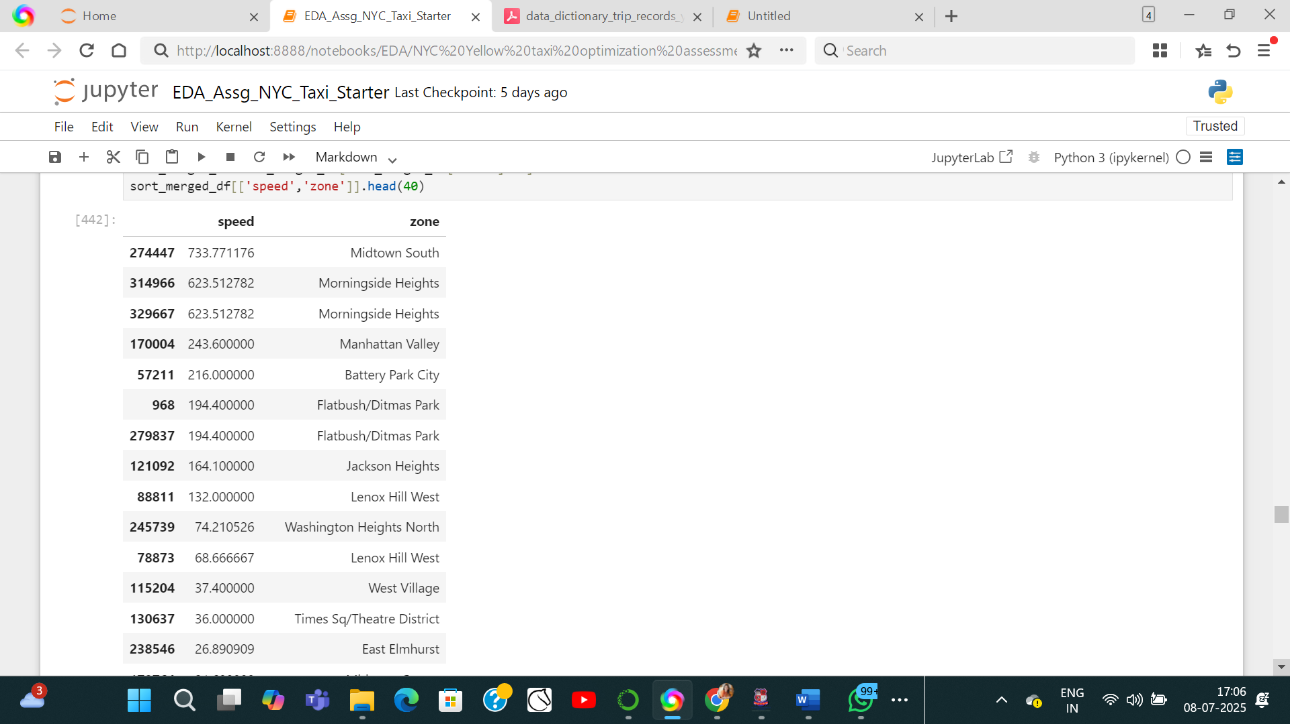

* + 1. **Calculate the hourly number of trips and identify the busy hours**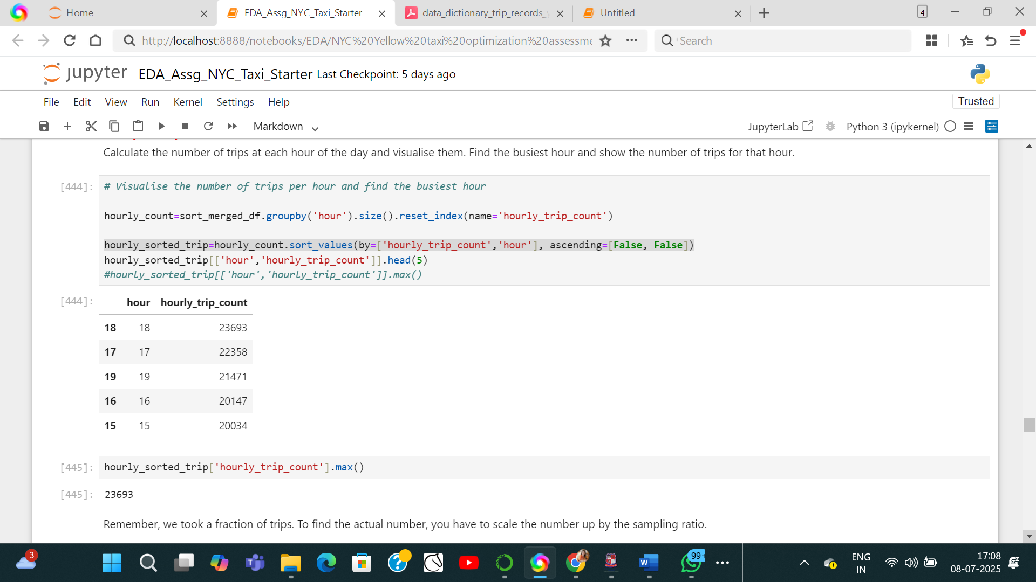
    2. **Scale up the number of trips from above to find the actual number of trips**

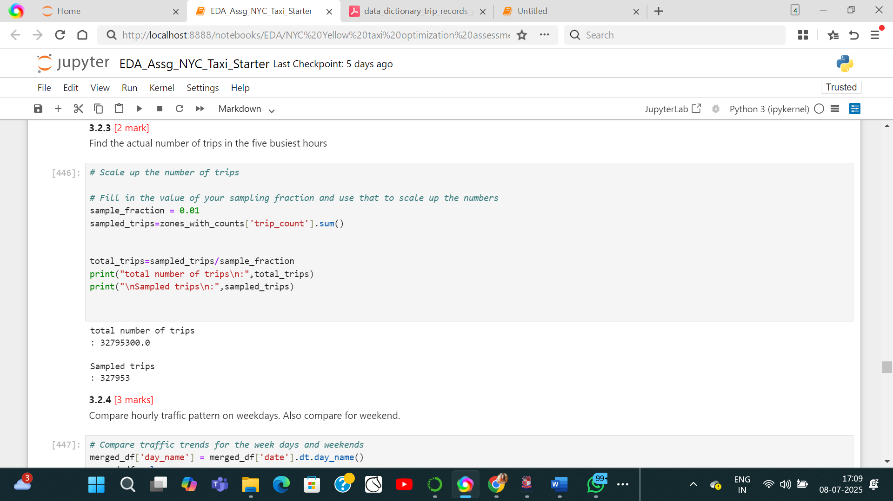

* + 1. **Compare hourly traffic on weekdays and weekends**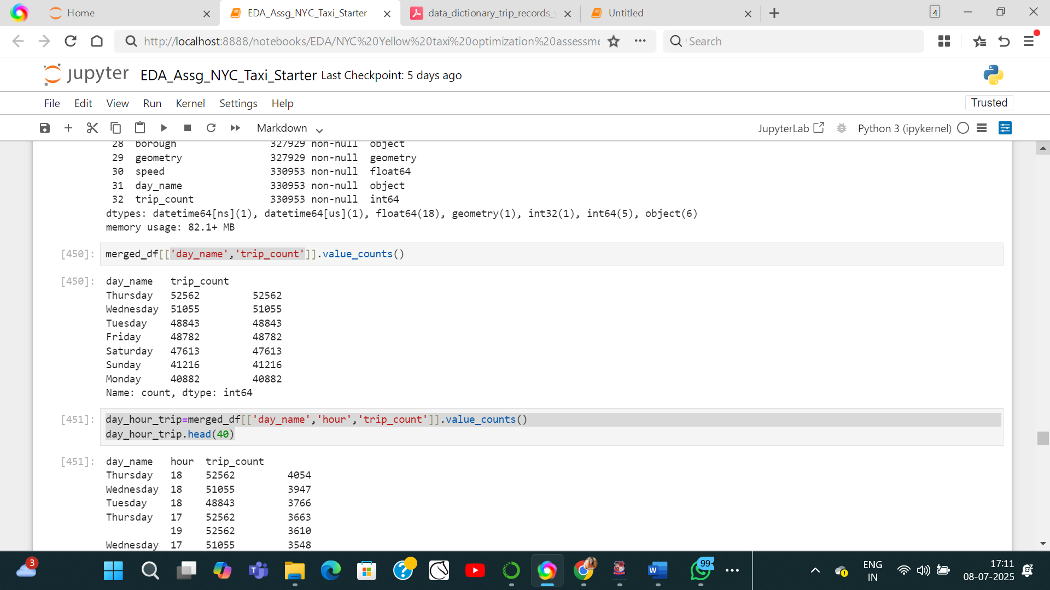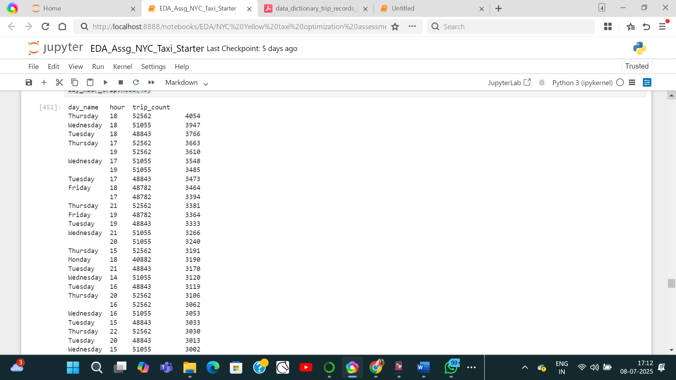
    2. **Identify the top 10 zones with high hourly pickups and drops**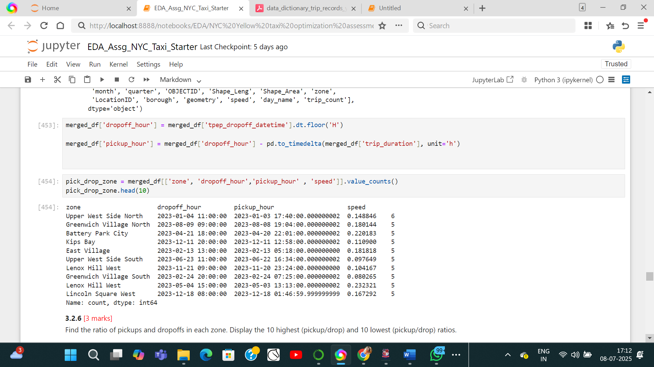
    3. **Find the ratio of pickups and dropoffs in each zone**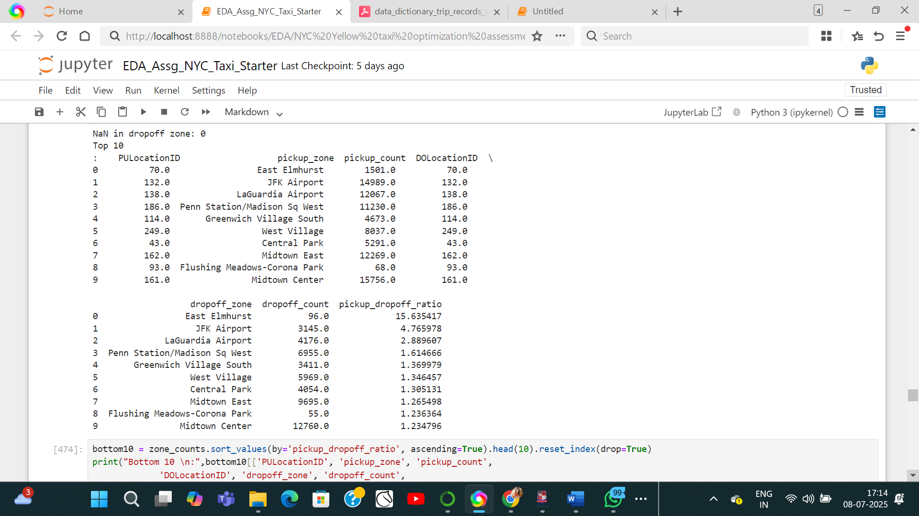
    4. **Identify the top zones with high traffic during night hours**Night hours are considered from hours<4th and >22nd on the scale of 0 to 23.

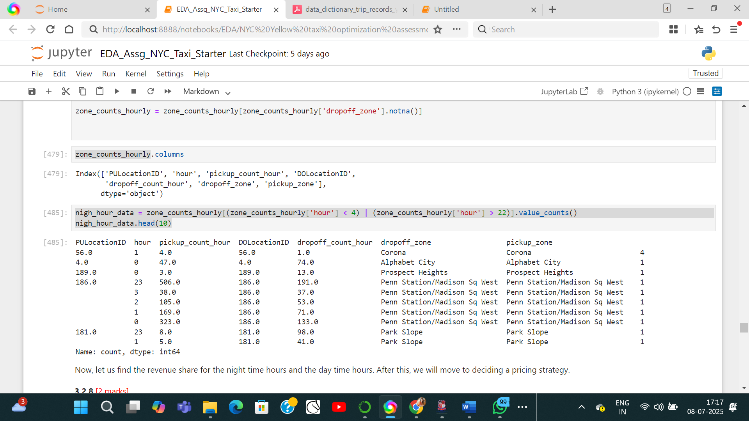

* + 1. **Find the revenue share for nighttime and daytime hours**Total amount(Dat time): 9783594.000000004

Total amount(Night time): 1073475.9300000002

**For the different passenger counts, find the average fare per mile per passenger**Trips with 1 passenger

Total amount for trips with 1 passenger is: 7377952.77

Total distance in miles for trips with 1 passenger is: 870686.84

Hance per mile fare is: 8.473715727689187

Therefore, fare per mile per passenger will be : 8.473715727689187 USD/mile

Trips with 2 passenger

Total amount for trips with 2 passenger is: 1608448.38

Total distance in miles for trips with 2 passenger is: 198926.78

Hance per mile fare is: 8.085630200217386

Therefore, fare per mile per passenger will be : 4.042815100108693 USD/mile

Trips with 3 passenger

Total amount for trips with 3 passenger is: 377650.14

Total distance in miles for trips with 3 passenger is: 45007.09

Hance per mile fare is: 8.390903299902305

Therefore, fare per mile per passenger will be : 2.796967766634102 USD/mile

Trips with 4 passenger

Total amount for trips with 4 passenger is: 204198.07

Total distance in miles for trips with 4 passenger is: 24942.83

Hance per mile fare is: 8.186644017539308

Therefore, fare per mile per passenger will be : 2.046661004384827 USD/mile

Trips with 5 passenger

Total amount for trips with 5 passenger is: 131340.47

Total distance in miles for trips with 5 passenger is: 15248.56

Hance per mile fare is: 8.613303157806376

Therefore, fare per mile per passenger will be : 1.7226606315612751 USD/mile

Trips with 6 passenger

Total amount for trips with 6 passenger is: 84004.17

Total distance in miles for trips with 6 passenger is: 9587.18

Hance per mile fare is: 8.762135476751244

Therefore, fare per mile per passenger will be : 1.460355912791874 USD/mile

**Average per passenger per mile fare is: 3.4238626905283263**

* + 1. **Find the average fare per mile by hours of the day and by days of the week**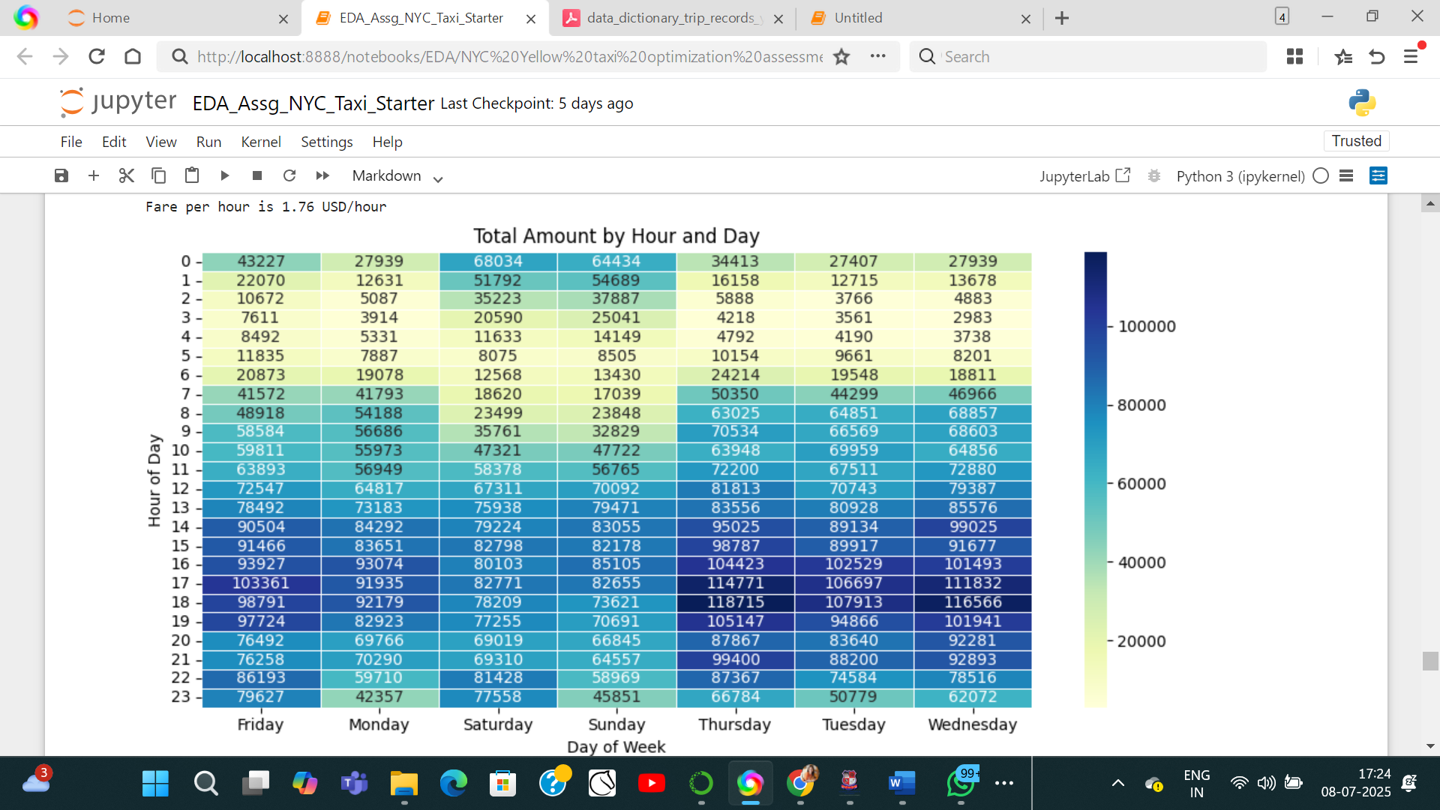
    2. **Analyse the average fare per mile for the different vendors**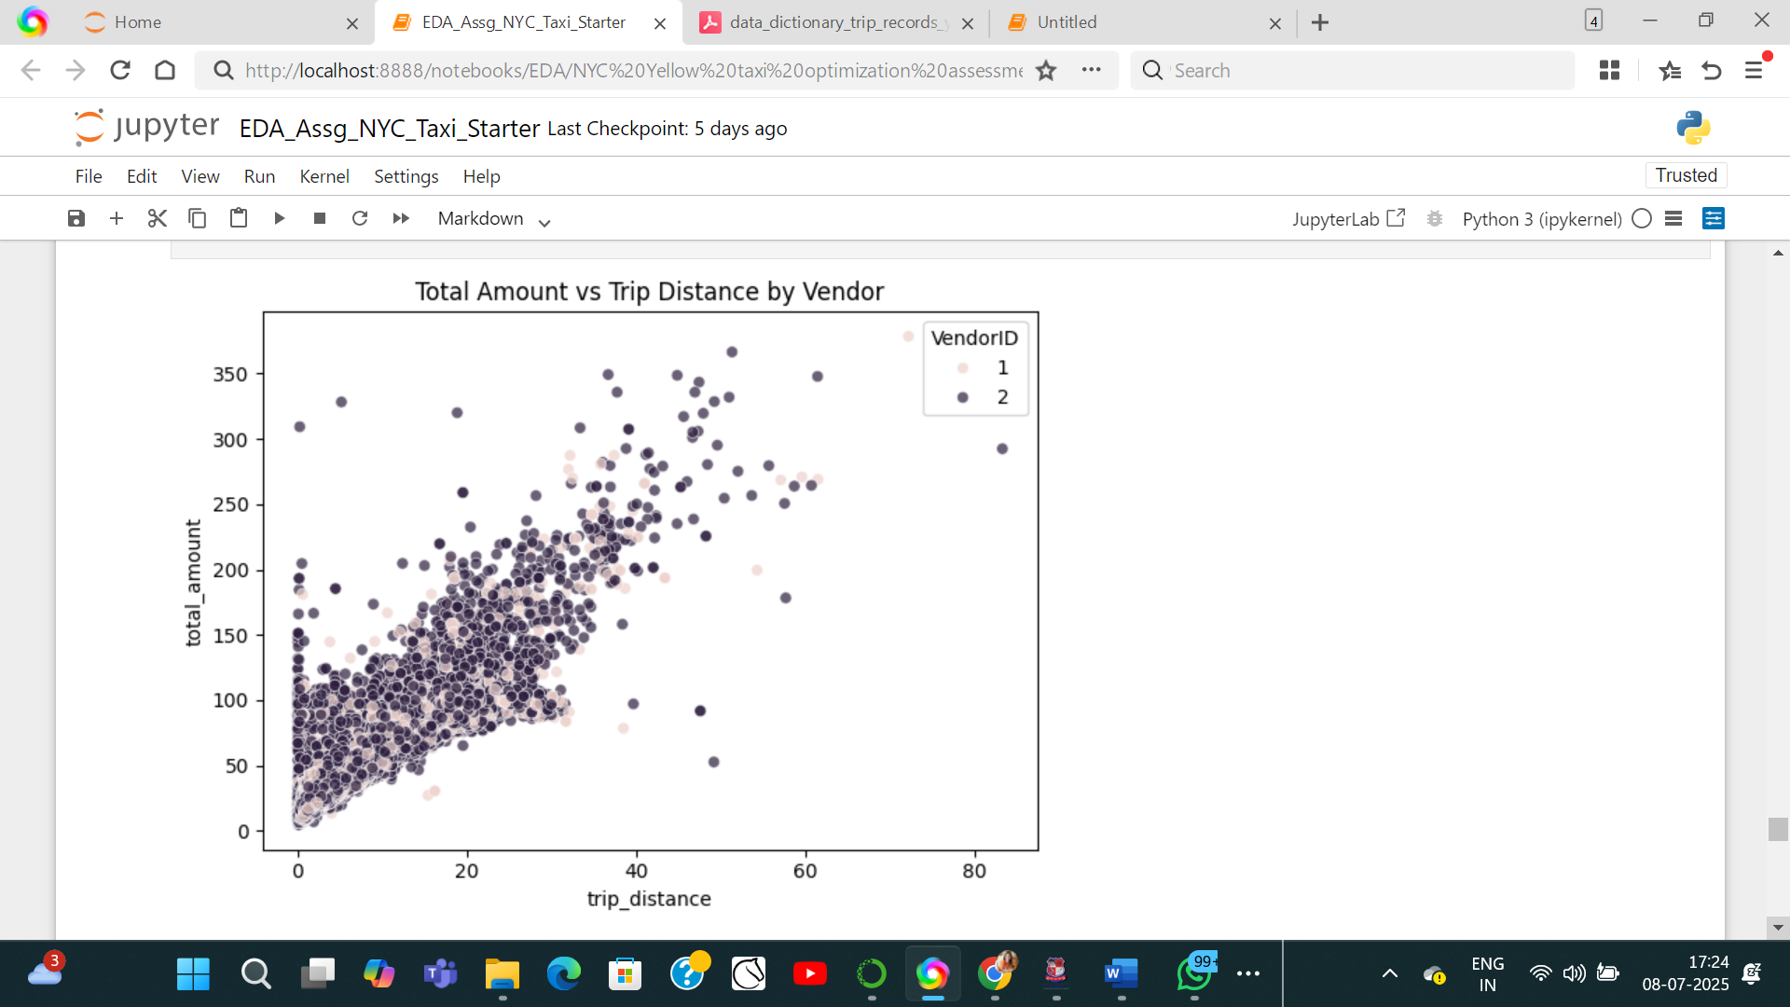
    3. **Compare the fare rates of different vendors in a distance-tiered fashion**
    4. **Analyse the tip percentages**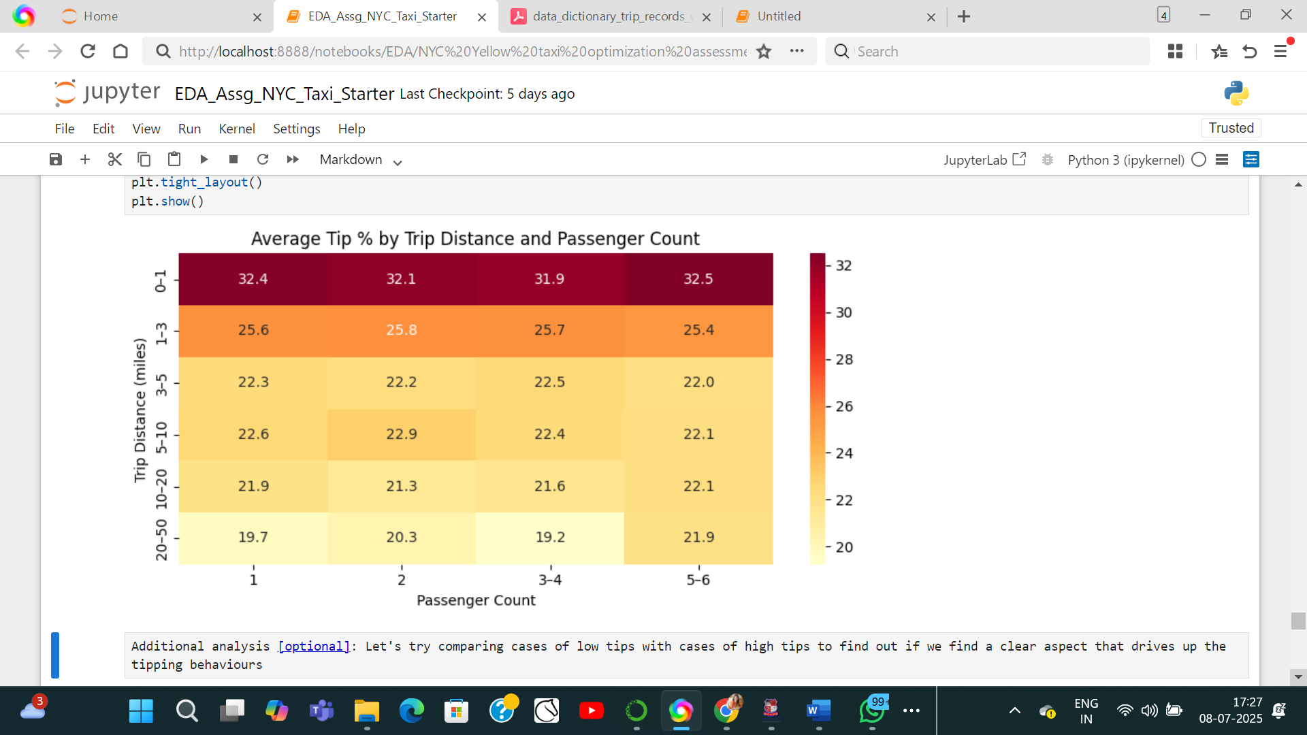
    5. **Analyse the trends in passenger count**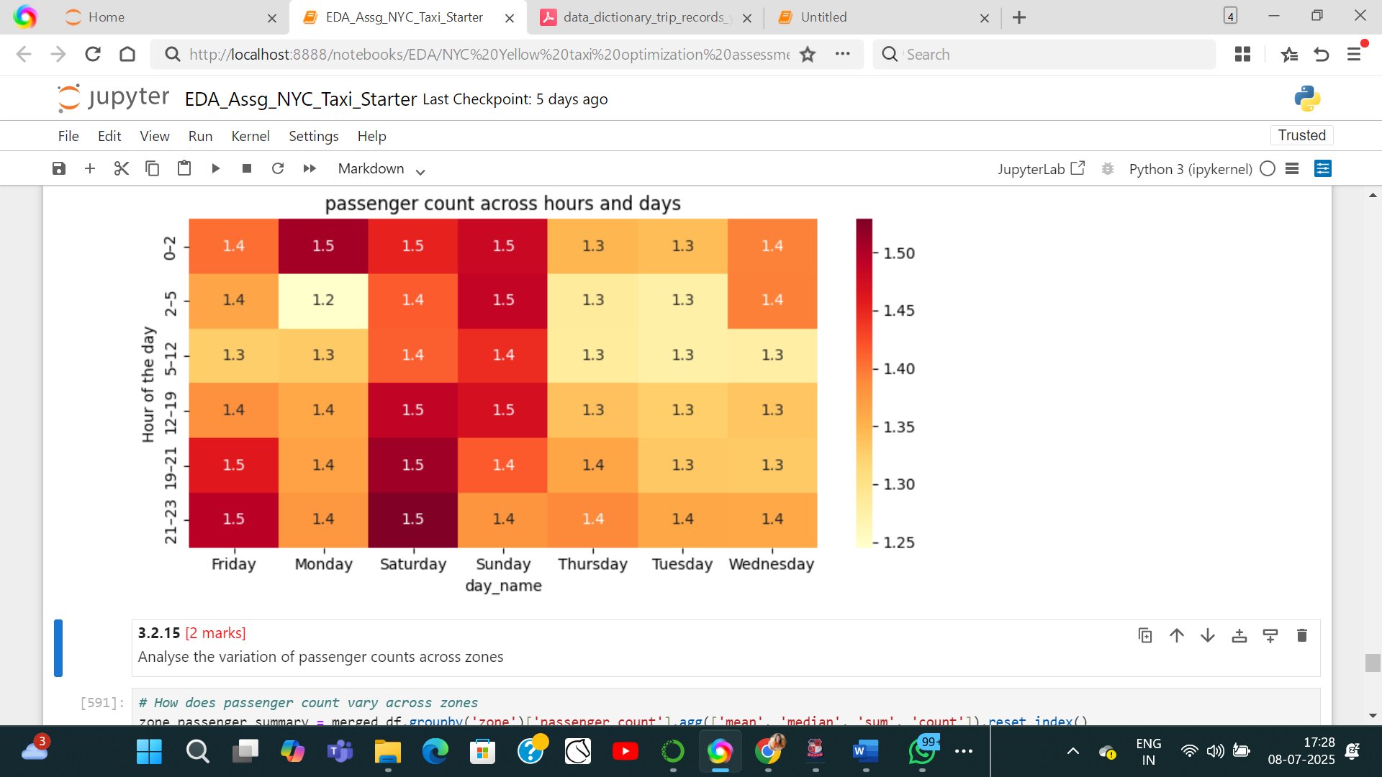
    6. **Analyse the variation of passenger counts across zones  
         
       Due to the size, whole graph is not inserted here.**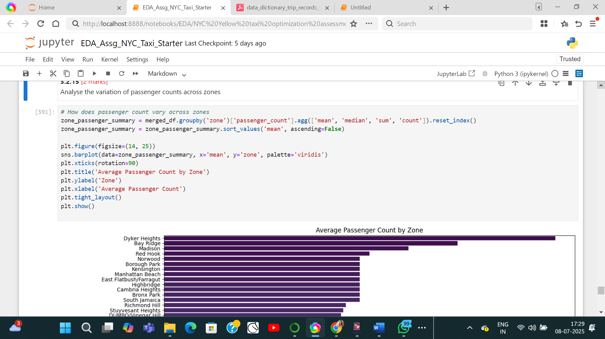
    7. **Analyse the pickup/dropoff zones or times when extra charges are applied more frequently.**

**improvement_surcharge**

count 330953.000000

mean 0.999588

std 0.017172

min 0.000000

25% 1.000000

50% 1.000000

75% 1.000000

max 1.000000

**congestion_surcharge**

count 330953.000000

mean 2.371087

std 0.552867

min 0.000000

25% 2.500000

50% 2.500000

75% 2.500000

max 2.500000

**extra**

count 330953.000000

mean 1.643726

std 1.838072

min 0.000000

25% 0.000000

50% 1.000000

75% 2.500000

max 14.250000

## Conclusions

### Final Insights and Recommendations

* + 1. **Recommendations to optimize routing and dispatching based on demand patterns and operational inefficiencies.**
    2. **Suggestions on strategically positioning cabs across different zones to make best use of insights uncovered by analysing trip trends across time, days and months.**
    3. **Propose data-driven adjustments to the pricing strategy to maximize revenue while maintaining competitive rates with other vendors.**